HANOI UNIVERSITY OF SCIENCE AND TECHNOLOGY
SCHOOL OF INFORMATION AND COMMUNICATION TECHNOLOGY

GRADUATION RESEARCH REPORT (GR1)
Topic: Design and Development of a Web-Based Fitness Platform for Beginner Gym Users
Project Code Name: FiFB (Fitness for Beginners)

NGÔ ĐỨC HUY
Huy.nd235946@sis.hust.edu.vn
Program: Global ICT

Supervisor: Professor Cao Tuan Dung
Department: 503-B1 Building
School: School of Information and Communications Technology

HANOI, 07/2026

Table of Contents
Chapter 1 – Introduction 6
1.1 Context 6
1.2 Problem Statement and Practical Significance 6
1.3 Contribution and Position Regarding Novelty 7
1.4 Motivation and Development Orientation 7
1.5 Objectives and Scope of GR1 8
1.6 Research and Development Method 9
1.7 Planned Roadmap from GR1 to GR2 9
Chapter 2 – Survey and Related Products 11
2.1 Survey Method and Evaluation Criteria 11
2.2 JEFIT 11
2.3 Hevy 11
2.4 ABC Trainerize 11
2.5 ExerciseDB as a Data Source 12
2.6 Functional Comparison 12
2.7 Frontend and User-Experience Comparison 13
2.8 Derived Product Direction and Quality Attributes 13
Chapter 3 – Theoretical Foundations and Technology Stack 14
3.1 End-to-End Technical Workflow 14
3.2 Client–Server Architecture and RESTful Communication 15
3.3 Frontend Technology Stack 16
3.4 Authentication, JWT, and Password Protection 16
3.5 Role-Based Access Control 16
3.6 Relational Database Design and Supabase Hosting 17
3.7 ExerciseDB V1 API Data Acquisition and Processing 17
3.8 Backend Technology Stack 18
3.9 Validation, Testing, and Code-Quality Support 18
3.10 Technology Summary and Scope Boundary 18
Chapter 4 – Design and Development of FiFB 19
4.1 Product Overview and Actors 19
4.2 Functional Requirements 20
4.2.1 Visitor Requirements 20
4.2.2 User Requirements 20
4.2.3 Trainer Requirements 21
4.2.4 Admin Requirements 21
4.3 Non-Functional Requirements 22
4.4 System Architecture and Project Structure 23
4.5 Database Design 24
4.6 Backend Design and Implementation 25
4.6.1 API Resource Groups 25
4.6.2 Request Processing Pipeline 26
4.6.3 Authentication and Role Flow 26
4.6.4 User and Exercise Management 27
4.6.5 Exercise Taxonomy 27
4.6.6 Data Access and Error Handling 27
4.7 Frontend Design and Implementation 27
4.7.1 Routing and Layout Separation 27
4.7.2 API Client and Authentication State 28
4.7.3 Search, Filters, and Exercise Details 28
4.7.4 Administrative and Trainer Interfaces 28
4.7.5 Reusable UI Components 28
4.8 Principal End-to-End Workflows 29
4.8.1 Login and Session Establishment 29
4.8.2 User Exercise Lookup 29
4.8.3 Trainer Submission and Admin Moderation 29
4.8.4 Admin User Governance 29
Chapter 5 – Results and Evaluation 30
5.1 Results Achieved in GR1 30
5.2 Exercise Data Acquisition Result 30
5.3 System Operation 30
5.4 Application Interfaces 31
5.6 Qualitative Evaluation of Software Quality 34
5.7 Limitations 35
5.8 Development Plan for GR2 35
References 37
Appendices 39
Appendix A – Core API Documentation 39
Appendix B – Database Schema 39
Appendix C – Focused Repository Structure 39

LIST OF ABBREVIATIONS
Abbreviation | Full Term
API | Application Programming Interface
CI/CD | Continuous Integration / Continuous Delivery
CORS | Cross-Origin Resource Sharing
CRUD | Create, Read, Update, Delete
CSS | Cascading Style Sheets
DBMS | Database Management System
ERD | Entity–Relationship Diagram
FR | Functional Requirement
GIF | Graphics Interchange Format
GR1 | Graduation Research 1
GR2 | Graduation Research 2
HTML | HyperText Markup Language
HTTP | HyperText Transfer Protocol
JSON | JavaScript Object Notation
JWT | JSON Web Token
MVP | Minimum Viable Product
NFR | Non-Functional Requirement
OTP | One-Time Password
RBAC | Role-Based Access Control
REST | Representational State Transfer
RDBMS | Relational Database Management System
SPA | Single-Page Application
SQL | Structured Query Language
UI/UX | User Interface / User Experience
UUID | Universally Unique Identifier

Chapter 1 – Introduction

1.1 Context
Physical activity plays an important role in maintaining health, yet many people still do not meet recommended activity levels. According to the World Health Organization, around 31% of adults worldwide were insufficiently active in 2022 [1], [2]. Although digital platforms cannot replace medical advice or professional coaching, they can make exercise information easier to access by providing clear instructions, visual demonstrations, and structured guidance.
The growth of digital fitness services has changed how people discover exercises, track progress, and communicate with trainers. However, many existing applications are designed for experienced users, professional coaches, or commercial training programs. As a result, beginners may find them difficult to use when they only need basic information about exercise techniques, target muscles, and required equipment.
FiFB, or Fitness for Beginners, is developed as the foundation of a web-based fitness community. Rather than managing a specific gym facility, the system aims to help users access structured exercise information and gradually connect with trainers and other community members. In GR1, the project focuses on the essential technical foundation, including role-based access control, authentication, relational database design, exercise taxonomy, and core management functions. Advanced features such as artificial intelligence and automated training recommendations are reserved for future development.

1.2 Problem Statement and Practical Significance
FiFB addresses three major pain points that currently hinder fitness enthusiasts. First, exercise information is highly fragmented. Because instructions, target muscles, and equipment requirements are scattered across different websites and social media platforms, beginners often struggle to verify if two different names refer to the same movement or if an exercise suits their available gear. Second, existing platforms lack an intuitive discovery mechanism. Without a structured taxonomy and a clean interface that pairs search filters with direct visual demonstrations, navigating large exercise libraries quickly becomes overwhelming. Finally, there is a clear gap in content governance. A community-driven platform needs to leverage professional expertise without sacrificing data integrity. FiFB solves this by establishing separate User, Trainer, and Admin roles, complete with a dedicated moderation workflow to vet trainer contributions before they go live.
The practical significance of this project lies in building a trustworthy, centralized hub for fitness knowledge. Users benefit from a seamless, one-stop lookup experience, trainers get a structured channel to share their expertise, and administrators can easily maintain content quality. Furthermore, because the system is built on a modern web architecture with RESTful APIs, the backend can easily support future mobile or web integrations. This ensures that FiFB is not just a temporary academic prototype, but a highly scalable foundation ready to evolve into a real-world community platform.

1.3 Contribution and Position Regarding Novelty
FiFB does not claim algorithmic or scientific novelty at the GR1 stage. No artificial-intelligence model, new optimization method, or original exercise-recognition algorithm is implemented in the evaluated scope. Presenting ordinary CRUD operations as a research innovation would therefore be inaccurate. Instead, the contribution of GR1 is application-oriented and architectural: the project consolidates a structured exercise dataset, an explicit three-role authorization model, a layered backend, a role-specific frontend, and a normalized database into a functioning platform foundation.
The distinguishing direction of FiFB is the intended combination of beginner-oriented exercise discovery and community support. Existing products often specialize in workout logging, coach-business management, or curated training content. FiFB begins with a simpler knowledge and governance core that can later support trainer interaction, social features, and AI-assisted guidance without replacing the underlying user, exercise, and taxonomy modules. The contribution is consequently expressed through integration, scope discipline, and extensibility rather than through an unsupported claim of technical novelty.

1.4 Motivation and Development Orientation
The topic was selected because it aligns with current market trends, practical user needs, personal interest, and the potential usefulness of the resulting product. Fitness services are increasingly delivered through digital channels, while beginner users continue to require accessible explanations and trustworthy guidance. The project therefore represents a practical intersection between software engineering and an application domain with visible social relevance.
Personal experience with beginner fitness difficulties also contributed to the choice of topic, although this experience was limited and is not treated as formal empirical evidence. It nevertheless highlighted common questions such as how to identify an appropriate exercise, how to understand the relationship between an exercise and a muscle group, and how to obtain assistance when information from informal online sources is inconsistent. These observations motivated the construction of a product that prioritizes structured information and clear interaction flows.
The long-term aspiration is to develop FiFB into a fitness community in which users can be supported either directly by trainers or indirectly through the platform’s data and intelligent services. GR1 establishes the technical foundation; GR2 is expected to investigate AI-assisted functions such as personalized exercise recommendations, conversational guidance, or other forms of context-aware support. These functions will only be introduced after their requirements, data quality, safety boundaries, and evaluation methods have been defined.

1.5 Objectives and Scope of GR1
The primary objective of GR1 is to design and implement a demonstrable web-platform foundation. The system must support account registration and login, identify the current actor, enforce role-based access for User, Trainer, and Admin, store exercise data in a relational model, provide administrative management of users and exercises, allow Trainer exercise submissions, and enable users to search, filter, and inspect exercise information. The objective also includes organizing the codebase so that later community and AI functions can be added without redesigning the complete application.
Table 1.1. Evaluated GR1 scope and explicit boundaries
Scope area | Included in GR1 | Boundary
Authentication | Registration, login, token refresh, logout, basic account verification and recovery support | The report evaluates login and role access as the principal flows.
User role | Profile access, exercise search, taxonomy filters, pagination, and exercise details | Workout recommendation and AI coaching are not evaluated in GR1.
Trainer role | Basic trainer profile and submission of exercise content for review | Advanced trainer–client business workflows are outside the focused scope.
Admin role | User-status management, exercise creation and update, moderation, and taxonomy maintenance | The system does not manage a physical gym or individual gym machines.
Data layer | Users, trainer profiles, exercises, body parts, muscles, equipment taxonomy, and junction tables | Equipment represents exercise metadata rather than facility inventory.
Architecture | React client, Express API, PostgreSQL database hosted through Supabase, and modular code structure | Redis, Socket.IO, deployment automation, and other extensions are not required as GR1 evidence.

1.6 Research and Development Method
The project follows an iterative software-engineering method. The process begins with problem analysis and a survey of representative fitness products. The survey is used to identify interaction patterns, role models, data requirements, and usability characteristics that are relevant to beginner users. The resulting requirements are then translated into a client–server architecture, a relational schema, use cases, and role-specific interface flows.
Implementation proceeds from the data and backend foundation to the frontend interaction layer. Exercise data are acquired through the ExerciseDB V1 API Free Version, normalized, and persisted to a Supabase-hosted PostgreSQL database. Backend modules expose validated REST endpoints, while the React client consumes those endpoints through a centralized Axios layer. Verification is performed primarily through scenario-based functional demonstration. Automated testing libraries and linting tools are configured in the repository, but no complete benchmark dataset or formal performance measurement was supplied for this report; therefore, the evaluation remains transparent about its qualitative nature.
Table 1.2. Research and development stages
Stage | Main activity | GR1 output
Problem analysis | Identify beginner-user difficulties and actor responsibilities | Problem statement and scope boundary
Market survey | Examine fitness libraries, trackers, coaching systems, and interface approaches | Derived product and quality requirements
Data preparation | Acquire ExerciseDB data through API, normalize fields, and create taxonomy mappings | Persistent exercise dataset in Supabase PostgreSQL
System design | Define architecture, roles, database relationships, APIs, and interface structure | Design models and implementation plan
Implementation | Develop modular Express backend and React frontend | Working foundation demo
Evaluation | Execute principal user, trainer, and administrator scenarios | Completion assessment, limitations, and GR2 plan

1.7 Planned Roadmap from GR1 to GR2
Table 1.3. GR1–GR2 development roadmap
Phase | Primary emphasis | Expected outcome
GR1 | Platform foundation, role model, relational database, authentication, user administration, exercise management, trainer submission, and exercise lookup | A stable and demonstrable web foundation with clearly defined scope
GR2 | Refinement of community interaction, systematic testing, improved UI/UX, data-quality controls, and carefully scoped AI-assisted user support | An evaluated community-oriented product extension built on the GR1 architecture

This roadmap deliberately places artificial intelligence after the platform and data foundation. AI functions are meaningful only when user roles, data provenance, access control, and core interactions are sufficiently stable. The separation also allows GR1 to be evaluated against concrete software-engineering objectives rather than speculative future functions.

Chapter 2 – Survey and Related Products

2.1 Survey Method and Evaluation Criteria
The market survey covers several products representing different parts of the digital fitness ecosystem. JEFIT is examined as a workout planner and exercise database, Hevy as a workout tracker with social features, ABC Trainerize as a coach–client platform,. ExerciseDB is considered separately as a data source rather than a direct competitor. The comparison focuses on both functional aspects, such as exercise search, workout tracking, trainer interaction, and community support, and frontend aspects, including navigation, visual presentation, information density, and ease of use for beginners [3]–[7].

2.2 JEFIT
JEFIT combines workout planning, exercise information, training logs, and progress tracking in a single platform [3]. Its large exercise library and structured workout data provide a useful reference for FiFB. However, the number of planning and tracking features may feel overwhelming to beginners who only need to understand how an exercise is performed, which muscles it targets, and what equipment it requires. FiFB should therefore make search, filtering, visual demonstrations, and concise exercise details available before introducing more advanced workout-planning functions.

2.3 Hevy
Hevy focuses on simple workout logging, routine creation, progress statistics, and social interaction [4]. Its clean and mobile-friendly interface shows how community features can be added without making the main workflow difficult to understand. This direction is relevant to FiFB’s long-term goal of becoming a fitness community. Nevertheless, because Hevy is primarily a workout tracker, FiFB should adopt its interface clarity and social orientation while keeping detailed training logs outside the main GR1 scope.

2.4 ABC Trainerize
ABC Trainerize is designed for fitness professionals who create training programs, monitor clients, and communicate with them remotely [5]. It provides a useful example of how trainer and client responsibilities can be separated through different interfaces and permissions. However, its workflow is strongly centered on professional coaching and business operations. In FiFB, the Trainer role is more limited during GR1 and mainly supports profile management and exercise-content submission. More complete trainer–user interaction can be developed when the community features are expanded.

2.5 ExerciseDB as a Data Source
ExerciseDB V1 API Free Version provides a structured collection of more than 1,500 exercises with fields such as exercise name, animated GIF, body part, equipment, target muscle, secondary muscles, and instructions [7]. It is not an end-user community application and therefore does not provide FiFB’s account management, moderation, role separation, or interface design. Its value lies in reducing the cost of manually creating the initial exercise dataset.
Using an external API does not eliminate the need for local data engineering. FiFB must define its own identifiers, normalize taxonomy values, preserve relationships, handle duplicate records, record source information, and remain operational independently of the external response structure during ordinary user requests. For this reason, ExerciseDB data are imported into FiFB’s PostgreSQL database rather than fetched directly every time a user opens the exercise library.

2.6 Functional Comparison
Table 2.1. Functional comparison of representative fitness products
Criterion | JEFIT | Hevy | ABC Trainerize | FiFB
Primary purpose | Workout planning and tracking | Simple logging and social progress | Professional coach–client management | Beginner discovery and fitness community foundation
Exercise library | Extensive library and routines | Library supporting workout logging | Exercises used within trainer programs | Structured exercise records with GIFs and taxonomy
Search and filtering | Rich but integrated with many features | Exercise selection within logging flows | Program- and coach-oriented selection | Keyword, body-part, muscle, and equipment filters
Trainer interaction | Limited compared with coaching platforms | Community interaction rather than formal coaching | Core platform capability | Basic Trainer role in GR1; broader support planned
Content governance | Platform-managed content | Platform-managed exercise catalog | Professional and organizational control | Trainer submission with Admin moderation
Community orientation | Social and sharing features | Strong community emphasis | Client groups and coach communication | Long-term community objective
GR1 suitability | Reference for data depth | Reference for clarity and community | Reference for role separation | Focused integration of selected principles

2.7 Frontend and User-Experience Comparison
Table 2.2. Frontend and user-experience comparison
UX criterion | JEFIT | Hevy | ABC Trainerize | FiFB
Information density | High due to planning, logs, and analytics | Moderate and focused on workout entry | High because of business and coaching workflows | Keep the GR1 navigation small and role-specific
Primary navigation | Feature-rich multi-function structure | Direct access to routines, logging, and community | Separate professional and client workflows | Separate User, Trainer, and Admin layouts
Visual guidance | Exercise media and detailed data | Exercise visuals support logging | Media embedded in assigned programs | GIF and instructions must dominate the detail page
Beginner onboarding | Powerful but potentially complex | Relatively simple first-use flow | Requires coach/client context | Allow public browsing and simple search before advanced actions
Social interaction | Available as a supporting feature | Integrated into the core experience | Structured around coach–client relationships | Introduce community features incrementally after the core library
Role visibility | Mostly consumer-oriented | Mostly consumer-oriented | Explicit professional/client distinction | Make permissions and available actions explicit in each layout

JEFIT provides a reference for data depth, Hevy for focused interaction and community motivation, Trainerize for role separation. FiFB combines only the elements that support its own problem statement. This selective approach prevents the demo from becoming a collection of disconnected features.

2.8 Derived Product Direction and Quality Attributes
The market survey leads to a product direction centered on discoverability, clarity, governed contribution, and extensibility. The exercise library must be accessible through keyword search and structured filters. The detail interface must connect the exercise name, visual demonstration, instructions, target muscles, body parts, and equipment in one coherent view. Trainer participation must be possible without granting unrestricted publication rights, and administrators must be able to manage account status and content lifecycle.
The most important software quality attributes are usability, security, maintainability, data integrity, reliability, and extensibility. Usability requires role-specific navigation, visible loading and error states, and a low-complexity discovery flow. Security requires password hashing, authenticated requests, and backend authorization rather than frontend-only route hiding. Maintainability requires modular boundaries and reusable components. Data integrity requires normalized relationships and database constraints. Reliability requires predictable error responses and transaction control. Extensibility requires that future community and AI functions use the same stable identity, role, and exercise-data foundation.
For GR1, the product is therefore considered successful when the foundation can demonstrate the principal role flows and exercise discovery process. Features such as complete workout tracking, social feeds, real-time chat, and AI guidance remain valuable to the product vision but are not prerequisites for the current academic milestone.

Chapter 3 – Theoretical Foundations and Technology Stack

3.1 End-to-End Technical Workflow
The technical workflow begins after the problem and scope have been identified. The first engineering task is to determine the information required by the application. For FiFB, an exercise record must contain a stable identifier, name, visual demonstration, ordered instructions, source, lifecycle status, and relationships to body parts, equipment, target muscles, and secondary muscles. This information model drives both the data-acquisition process and the relational database design.
The second task is to obtain a sufficiently broad initial dataset. Instead of manually entering hundreds of exercise records, the project uses ExerciseDB V1 API Free Version. The source data are requested page by page, normalized into the FiFB schema, and stored in a Supabase-hosted PostgreSQL database. Once the local dataset exists, the user-facing application no longer depends on a live ExerciseDB request for each search. The backend queries FiFB’s own tables and applies authorization, status rules, filters, and pagination.
The third task is system design. The frontend and backend are separated into independent applications connected through HTTP. The backend is decomposed into modules and layers, while the database schema is normalized around stable domain entities. The frontend is decomposed into pages, layouts, routes, reusable components, API clients, and authentication state. This design is then implemented incrementally, beginning with authentication and common infrastructure before role-specific functions are added.
The final task is verification. Core flows are examined from the user interface to the database: a login request is validated and converted into an authenticated session; an administrator action is checked against the current role; an exercise search is translated into parameterized SQL; and the response is rendered as loading, success, empty, or error states. This end-to-end perspective is important because a function is not complete merely because one interface page or one API route exists in isolation.

3.2 Client–Server Architecture and RESTful Communication
FiFB follows a client–server architecture. The React application is responsible for presentation, navigation, local interaction state, and communication with the backend. The Express application exposes business capabilities through HTTP endpoints, validates requests, enforces permissions, and accesses persistent data. PostgreSQL, hosted through Supabase in the current deployment, stores the authoritative application state. The separation reduces direct coupling between the user interface and database structure and allows either side to evolve behind a stable API contract.
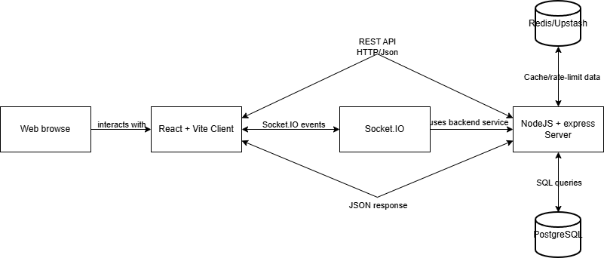
Figure 3.1. Designed client–server architecture of the FiFB repository
Figure 3.1 presents the overall system architecture, while the FiFB implementation mainly follows the React and Vite client → Node.js and Express server → PostgreSQL flow. Redis, Upstash, and Socket.IO are reserved for future features such as caching, notifications, and real-time communication.
The backend exposes RESTful APIs for authentication, users, trainers, exercises, and exercise taxonomy. Data are exchanged in JSON format, and list endpoints use pagination to improve performance and avoid loading the entire exercise dataset at once [17].

3.3 Frontend Technology Stack
React is used to build the main interfaces for authentication, exercise discovery, trainer activities, and administration [8]. React Router manages navigation, Axios handles API requests, and React Hook Form supports form processing [10], [11]. Tailwind CSS provides responsive styling, while Lucide React and Sonner support icons and notifications [12], [24].
This stack is suitable for the GR1 prototype because it supports rapid development while maintaining clear separation between pages, components, state management, and API communication.

3.4 Authentication, JWT, and Password Protection
FiFB uses email and password authentication. Passwords are hashed with bcryptjs before being stored, while JSON Web Tokens are used to identify authenticated accounts and their roles [18], [19]. Protected requests include the access token in the Authorization header, and backend middleware verifies the token before allowing access to restricted functions.
The Axios client automatically attaches access tokens and attempts to refresh expired sessions [11]. When token renewal fails, the application clears the current session and redirects the user to the login page. Although frontend route guards improve navigation, actual security is enforced by the backend API.

3.5 Role-Based Access Control
FiFB defines three main roles: User, Trainer, and Admin. Users access exercise information and personal functions, Trainers can manage their profiles and contribute exercise content, while Admins are responsible for user accounts, exercise records, and content moderation.
Access control is applied at both backend and frontend levels. Backend middleware and service rules prevent unauthorized operations, while the frontend displays only the routes and actions available to the current role. Database constraints provide an additional level of protection for valid roles, statuses, and relationships.

Table 3.1. Core role model
Actor | Core GR1 permissions | Explicit restriction
Visitor | Browse public exercises, inspect details, register, and log in | Cannot access profile or management operations
User | Manage own profile and use exercise discovery functions | Cannot manage other accounts or publish administrative content
Trainer | Use exercise discovery, maintain a trainer profile, and submit exercise content | Cannot directly approve submissions or administer users
Admin | Manage account status, exercise lifecycle, moderation, and taxonomy data | Administrative power remains subject to validation and auditability

3.6 Relational Database Design and Supabase Hosting
PostgreSQL is used because FiFB contains several related entities, including users, trainer profiles, exercises, body parts, muscles, and equipment categories [15]. Many-to-many relationships are represented through junction tables, while foreign keys and constraints maintain consistency between records. The backend uses the pg driver and explicit SQL queries, which makes the database interactions clear and suitable for the objectives of GR1.
The database is hosted on Supabase, but the Express server remains responsible for business logic and authorization [16]. Exercise taxonomy is normalized into separate tables to reduce duplication and support filtering. UUID identifiers, status fields, indexes, parameterized queries, and transactions are used to improve consistency and maintainability.

3.7 ExerciseDB V1 API Data Acquisition and Processing
The initial exercise dataset was collected from the ExerciseDB V1 API Free Version and successfully stored in the Supabase PostgreSQL database. The process uses structured API responses rather than HTML scraping, although it may still be referred to informally as data crawling.
The import script retrieves records in pages, validates essential fields, and updates or inserts exercises using their external identifiers. Body parts, equipment, target muscles, and secondary muscles are normalized and linked through the appropriate junction tables. Transactions ensure that an exercise and its related taxonomy mappings are updated consistently.
The script also records successful, skipped, updated, and failed items. Because the exact imported record count was not preserved, the report confirms the successful import without presenting an unsupported numerical result.

3.8 Backend Technology Stack
The backend is implemented with Node.js and Express.js [13], [14], [24]. Its modular structure separates routes, controllers, services, repositories, and validation schemas, making the code easier to maintain and extend.
PostgreSQL access is handled through pg, while Zod validates incoming data [20]. JWT and bcryptjs support authentication, Helmet and CORS improve API security, and logging, compression, and rate-limiting libraries support system operation. Redis, Socket.IO, and SendGrid belong to the broader system design and are treated as future extension technologies rather than core GR1 requirements.

3.9 Validation, Testing, and Code-Quality Support
The repository includes ESLint and Prettier for code consistency, Jest for unit testing, and Supertest for API integration testing [22]–[24]. These tools provide a basic quality-assurance foundation for both frontend and backend development.

3.10 Technology Summary and Scope Boundary
Table 3.2. Technology stack summary
Layer | Technology | Repository version or role
Frontend | React | 18.3.1; component-based UI
Frontend build | Vite | 6.0.5; development server and production build
Routing | React Router DOM | 6.28.1; public, protected, and role routes
HTTP client | Axios | 1.7.9; API calls and token interception
Forms and UI | React Hook Form, Tailwind CSS, Lucide React, Sonner | Form state, responsive styling, icons, and notifications
Backend runtime | Node.js | Version 20 or later
Backend framework | Express.js | 4.21.2; routes and middleware
Database | PostgreSQL hosted through Supabase | Relational persistence accessed through pg
Security | JWT, bcryptjs, Helmet, CORS, rate limiting | Authentication and defensive controls
Validation | Zod | Request schema validation
Quality support | ESLint, Prettier, Jest, Supertest | Static checks and automated-test capability
Extensions | Redis/Upstash, Socket.IO, SendGrid, Docker, CI/CD | Broader repository support; not core GR1 evidence

Chapter 4 – Design and Development of FiFB

4.1 Product Overview and Actors
FiFB is a web-based fitness platform intended to evolve into a community that supports beginner gym users. In the GR1 implementation, the product centers on a structured exercise library and a controlled contribution model. Public visitors can inspect exercise information and create accounts. Authenticated users receive profile and discovery functions. Trainers obtain an additional profile and exercise-submission workflow. Administrators govern accounts, exercise content, and taxonomy data.
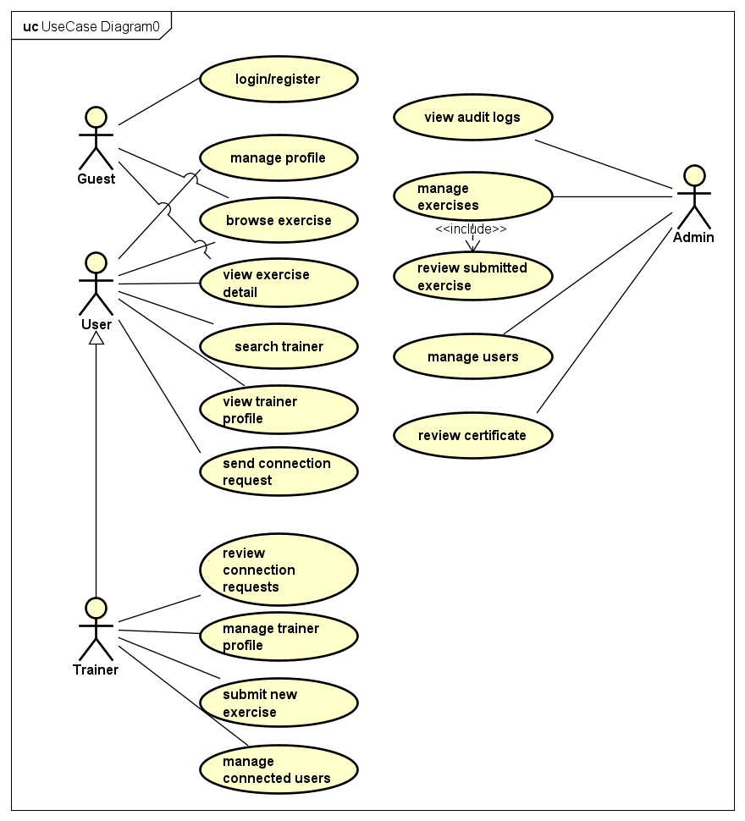
Figure 4.1. Use-case diagram created for the broader FiFB product design
The focused GR1 implementation and evaluation use only the subset associated with authentication, profiles, exercise discovery, trainer submission, user management, exercise moderation, and administrative governance.

4.2 Functional Requirements
Functional requirements specify the observable behavior expected from the system. They are grouped by actor because the same resource may be visible or editable under different rules. The descriptions below emphasize complete business flows rather than isolated interface buttons.

4.2.1 Visitor Requirements
An unauthenticated visitor must be able to access public authentication pages and browse active exercise content. The visitor can search and filter the exercise library and open a detail page containing the visual demonstration, instructions, body-part associations, muscles, and equipment. Registration must allow the creation of a User or Trainer account, after which the account can participate in the appropriate authenticated flows. A visitor must not be able to access another user’s profile or any management endpoint.
Table 4.1. Visitor functional requirements
ID | Requirement | Acceptance description
G-01 | Browse active exercises | The public library returns only content eligible for ordinary viewing.
G-02 | Search and filter | Keyword and taxonomy parameters can be combined with pagination.
G-03 | View exercise details | The detail page connects GIF, instructions, muscles, body parts, and equipment.
G-04 | Register and log in | A visitor can create an account and establish an authenticated session.

4.2.2 User Requirements
An authenticated User must be able to view and update permitted profile fields and use the exercise library without administrative complexity. Search results must respond to the current keyword, filter combination, and page. Selecting an exercise must open the complete information view. The user interface must expose only user-relevant navigation and must not display controls that imply authority to manage other accounts or publish content.
Table 4.2. User functional requirements
ID | Requirement | Acceptance description
U-01 | Manage own profile | The account can retrieve and update allowed personal fields.
U-02 | Search exercises | The system matches active exercise names and supported search fields.
U-03 | Filter exercises | Body part, target muscle, secondary muscle, and equipment filters are supported.
U-04 | View exercise details | The page displays structured instructions and taxonomy associations.
U-05 | Use role-appropriate interface | User routes and actions exclude Trainer- and Admin-only operations.

4.2.3 Trainer Requirements
A Trainer retains access to the shared exercise-discovery functions and gains a trainer-profile workflow. The profile can store information such as biography, specialization, and years of experience. A Trainer can submit a proposed exercise with the information needed for review. The submission must enter a pending state rather than becoming immediately visible as approved content. This requirement balances community contribution with platform governance.
Table 4.3. Trainer functional requirements
ID | Requirement | Acceptance description
T-01 | Maintain trainer profile | The Trainer can create or update professional profile information.
T-02 | Use exercise library | The Trainer can search, filter, and inspect the shared content.
T-03 | Submit exercise content | A new proposal is stored for administrative review.
T-04 | Use Trainer interface | Trainer-only pages are protected from ordinary User accounts.

4.2.4 Admin Requirements
An Admin must be able to retrieve a filtered and paginated user list, inspect an account, and change its lifecycle status. Administrative user management is status-based so that an account can be locked or disabled without deleting its history. The Admin must also be able to create and update exercises, review Trainer submissions, approve or reject content, and deactivate records that should no longer be available to ordinary users.
Taxonomy management supports the consistency of exercise metadata. Body parts, muscles, and equipment categories can be listed and maintained so that search filters use canonical values. Equipment management in this context is exclusively taxonomy management.
Table 4.4. Admin functional requirements
ID | Requirement | Acceptance description
A-01 | Manage user status | The Admin can list, filter, inspect, lock, unlock, or disable accounts.
A-02 | Create and update exercises | Administrative forms can maintain core content and taxonomy mappings.
A-03 | Moderate submissions | Pending Trainer content can be approved or rejected.
A-04 | Deactivate exercise content | Inactive content is excluded from ordinary public results.
A-05 | Maintain exercise taxonomy | Canonical body-part, muscle, and equipment values support consistent filtering.
A-06 | Use Admin interface | Administrative pages and API operations require the Admin role.

4.3 Non-Functional Requirements
Non-functional requirements define the quality constraints under which the functional behavior should operate. Because the present system is a GR1 demonstration, quantitative service-level objectives have not yet been measured. The requirements are therefore written as design and verification targets.
Table 4.5. Non-functional requirements
Quality attribute | Requirement for the GR1 foundation
Usability | Role-specific navigation, consistent forms, visible loading/error/empty states, and a direct exercise-discovery flow should minimize unnecessary steps.
Security | Passwords must be hashed; protected API operations must validate JWT and role; request data must be validated; browser origins must be controlled.
Data integrity | Primary keys, foreign keys, uniqueness rules, valid statuses, transactions, and normalized junction tables must prevent inconsistent records.
Maintainability | Backend responsibilities must be separated into routes, controllers, services, repositories, and validation; frontend responsibilities must be separated into API, pages, layouts, routes, contexts, hooks, and components.
Reliability | Unexpected routes and operational errors must produce controlled responses; one failed component or request should not make the complete application unusable.
Performance | List operations must use pagination and database queries should use indexes and bounded filtering; formal latency benchmarks remain future work.
Extensibility | Community, real-time, and AI functions should be addable without replacing the core identity, exercise, taxonomy, and authorization modules.
Portability | Environment variables and standard web technologies should allow local, containerized, or managed-database deployment.

4.4 System Architecture and Project Structure
The core architecture contains three runtime layers. The React and Vite client renders the user interface and communicates through JSON over HTTP. The Express server receives requests, applies middleware and business rules, and returns standardized responses. The Supabase-hosted PostgreSQL database stores accounts, profiles, exercises, taxonomy, and relationships. The backend is the only application layer that should execute business-sensitive database operations for the core web client.
The backend adopts a layered modular pattern. Routes define endpoint paths and middleware composition. Controllers translate HTTP input into service calls and format output. Services enforce business rules, lifecycle transitions, and authorization decisions. Repositories contain parameterized SQL and database mapping logic. Validation files define request schemas. This separation keeps HTTP concerns, domain decisions, and persistence logic from becoming a single monolithic module.
server/src/
├── config/ Environment and application configuration
├── db/ PostgreSQL pool, transactions, and database support
├── middlewares/ Authentication, roles, validation, errors, and security
├── modules/
│ ├── auth/ Registration, login, tokens, password workflows
│ ├── users/ Own profile and Admin user management
│ ├── trainers/ Trainer profile and core Trainer functions
│ ├── exercises/ Exercise discovery and content lifecycle
│ ├── exerciseTaxonomy/ Body parts, muscles, and equipment metadata
│ ├── admin/ Administrative review operations
│ └── ... Community and extension modules
├── redis/ Optional caching and distributed support
├── routes/ Root route registration
├── socket/ Optional real-time layer
├── utils/ Shared helpers
├── app.js Express application composition
└── server.js Process startup and server lifecycle
The frontend follows a feature-oriented presentation structure. API modules isolate endpoint details, while route components determine authentication and role access. Layouts provide different navigation frames for User, Trainer, and Admin. Page folders organize actor-specific screens, and reusable components maintain consistent behavior for tables, forms, feedback, and pagination.
client/src/
├── api/ Axios client and domain API functions
├── components/ Reusable UI components
├── contexts/ Authenticated account and shared state
├── hooks/ Reusable asynchronous and UI behavior
├── layouts/ Public, User, Trainer, and Admin layouts
├── pages/
│ ├── auth/ Login, registration, verification, recovery
│ ├── user/ Exercise library, details, and profile
│ ├── trainer/ Trainer profile and exercise submission
│ └── admin/ User, exercise, taxonomy, and support pages
├── routes/ AppRoutes, ProtectedRoute, and RoleRoute
├── styles/ Global styling support
├── utils/ Client-side utility functions
├── App.jsx Application root
└── main.jsx React bootstrap

4.5 Database Design
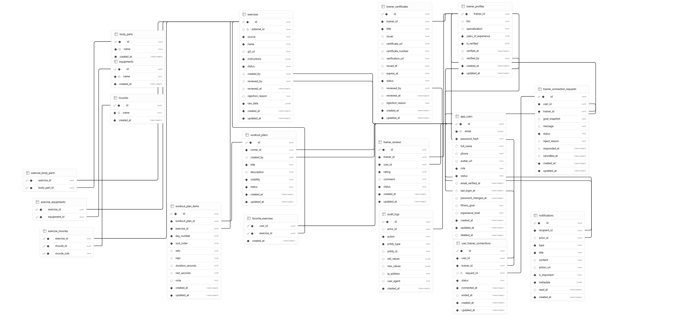
Figure 4.2. Entity–relationship diagram of the broader FiFB repository
The app_users table is the identity root. It stores email, password hash, role, account status, and basic profile data. trainer_profiles forms a one-to-one role extension so Trainer-specific attributes do not make every User record sparse. The exercises table stores the imported or administratively created exercise content, including source, external identifier, name, GIF URL, ordered instructions, status, and raw source data.
Body parts, equipment, and muscles are represented as independent taxonomy tables. exercise_body_parts and exercise_equipments model many-to-many relationships. exercise_muscles includes the semantic role target or secondary, which allows one muscle table to represent both categories without duplicating names. audit_logs provide traceability for sensitive administrative changes. Additional tables for favorites, workout planning, workout sessions, connections, certificates, reviews, chat, and notifications belong to the broader product design and are not necessary to prove the core GR1 flows.
Table 4.6. Core GR1 database entities
Core table | Responsibility | Principal relationships
app_users | Authentication identity, role, status, and basic profile | Referenced by trainer profile, submissions, and administrative history
trainer_profiles | Trainer-specific biography, specialization, and experience | One-to-one extension of app_users
exercises | Exercise content, media, instructions, source, and lifecycle | Connected to taxonomy through junction tables
body_parts | Canonical body-part classification | Many-to-many with exercises
equipments | Canonical equipment category required by an exercise | Many-to-many with exercises; not physical inventory
muscles | Canonical muscle names | Many-to-many with exercises through target/secondary roles
exercise_body_parts | Exercise-to-body-part mapping | Composite relationship table
exercise_equipments | Exercise-to-equipment mapping | Composite relationship table
exercise_muscles | Exercise-to-muscle mapping with semantic role | Composite relationship table
audit_logs | Traceability for sensitive administrative changes | References actor and affected operation where applicable

4.6 Backend Design and Implementation

4.6.1 API Resource Groups
The backend exposes resource groups for authentication, users, trainers, exercises, exercise taxonomy, and administrative operations. Authentication routes support registration, verification, login, current-user retrieval, token refresh, logout, password change, and password recovery. The GR1 evaluation gives greatest weight to login, current-user retrieval, and role enforcement, while the additional endpoints complete a practical account lifecycle.
Table 4.7. Core backend resource groups
Resource group | Representative operations | Role significance
Auth | Register, verify, login, refresh, logout, current account, password workflows | Public entry and authenticated session lifecycle
Users | Read/update own profile; list, inspect, and update account status | User self-service and Admin governance
Trainers | Read/update Trainer profile and submit exercise content | Trainer-specific contribution flow
Exercises | List, filter, read detail, create, update, review, reject, deactivate | Shared discovery and administrative lifecycle
Exercise taxonomy | List and maintain body parts, equipment, and muscles | Canonical metadata for filters and exercise relationships
Admin support | Moderation, traceability, and selected management operations | Restricted platform governance
Health | Return service availability status | Operational verification

4.6.2 Request Processing Pipeline
A request enters the Express application through global middleware. Security headers, origin control, body parsing, compression, and request logging are applied before domain routes. Route-level validation converts malformed parameters or bodies into controlled errors before business logic runs. Authentication middleware verifies the access token, and role middleware checks whether the current actor is permitted to continue.
The controller extracts the validated request context and delegates to a service. The service applies domain rules, such as allowable status transitions or the visibility of pending exercises. The repository executes parameterized SQL and returns database rows. The service transforms those rows into the response model, and the controller returns the standardized JSON envelope. Unknown routes and unhandled operational errors are processed by not-found and centralized error middleware so that the client receives a predictable structure.

4.6.3 Authentication and Role Flow
During login, the backend retrieves the account by email, verifies the bcrypt password hash, checks whether the account status permits access, and issues signed tokens containing the required identity and role claims. Subsequent protected requests carry the access token. The authenticate middleware verifies the token and loads the current identity context; role middleware then compares the route requirement with the stored role. Sensitive service functions repeat relevant ownership and status checks rather than relying solely on the route definition.
This flow supports defense in depth. The frontend can prevent a User from opening an Admin page, but a malicious client could ignore the frontend. The backend therefore remains authoritative. Likewise, database constraints protect against invalid values even if an application-level defect allows an inappropriate request to reach the repository.

4.6.4 User and Exercise Management
User management uses paginated and filterable queries so administrators can locate accounts without loading the entire table. Status updates represent administrative control while preserving the account record. The service layer must prevent inappropriate self-locking or invalid transitions where applicable and record sensitive changes for traceability. Ordinary users are limited to their own permitted profile fields.
Exercise management separates public visibility from the administrative lifecycle. Public list and detail queries return active records. Trainer submissions begin as pending. Administrators can create records directly, modify content and taxonomy mappings, approve or reject submissions, and deactivate outdated content. Multi-table updates should execute in a transaction because the exercise record and its taxonomy associations form one logical aggregate.

4.6.5 Exercise Taxonomy
The taxonomy module exposes body parts, muscles, and equipment values used by search filters and exercise forms. A taxonomy item is not treated as free text on every exercise because inconsistent capitalization or spelling would fragment the filter results. Administrative creation and maintenance preserve a canonical vocabulary. Equipment is defined only as exercise metadata, which is consistent with FiFB’s community purpose and avoids introducing irrelevant facility-management requirements.

4.6.6 Data Access and Error Handling
Repositories use parameterized SQL through node-postgres. Parameters are transmitted separately from query text, reducing the risk associated with constructing SQL from untrusted input. Pagination values and filters are validated before execution. Database errors are not exposed directly to the browser; the centralized error layer converts them into machine-readable codes, human-readable messages, and optional validation details. This boundary supports both security and frontend consistency.

4.7 Frontend Design and Implementation

4.7.1 Routing and Layout Separation
AppRoutes defines public, authenticated, and role-specific navigation. ProtectedRoute verifies that an authenticated account exists before rendering protected content, while RoleRoute checks whether the current role is included in the allowed set. Authenticated users are presented with layouts and navigation appropriate to User, Trainer, or Admin. The route structure therefore mirrors the backend role model and reduces the likelihood that an actor will be confused by unavailable actions.

4.7.2 API Client and Authentication State
The API layer separates page components from raw endpoint details. Each domain module exports functions for the requests used by its pages. A shared Axios instance defines the API base URL, credentials behavior, access-token injection, refresh handling, and normalized client errors. AuthContext stores the current account, login and logout operations, current-user reload behavior, and role-check helpers. Pages consume this context instead of independently parsing tokens or duplicating session rules.

4.7.3 Search, Filters, and Exercise Details
The exercise-library page maintains the current keyword, selected taxonomy filters, page, loading state, result set, and total-page information. A change in search conditions produces a bounded API request. The response is rendered as exercise cards or rows with clear empty and error states. The detail page presents the GIF, instructions, body parts, target muscles, secondary muscles, and equipment in one view, enabling the user to interpret the movement without navigating between unrelated pages.

4.7.4 Administrative and Trainer Interfaces
Administrative pages use reusable data-table, pagination, status-badge, form-field, and confirmation-dialog components. User management presents account identity, role, and status with controlled actions. Exercise management presents lifecycle and editing controls. Trainer pages isolate profile and submission activities from administrative moderation. The visual separation supports both usability and the conceptual integrity of the role model.

4.7.5 Reusable UI Components
Table 4.8. Shared frontend components
Component | Purpose in the core demo
ConfirmDialog | Require explicit confirmation before destructive or lifecycle-changing actions
DataTable | Provide a reusable structure for administrative lists
EmptyState | Explain when no records match the current conditions
ErrorBoundary | Prevent an unexpected React component error from breaking the complete interface
ErrorState | Present request failure and retry behavior consistently
FormField | Standardize labels, inputs, and validation messages
LoadingState | Provide visible feedback during asynchronous operations
PageHeader | Maintain consistent page titles and contextual actions
Pagination | Navigate bounded list responses
StatusBadge | Communicate account or content lifecycle states

4.8 Principal End-to-End Workflows

4.8.1 Login and Session Establishment
The actor submits email and password through the login form. The client validates required fields and sends the credentials to the authentication endpoint. The backend verifies the account and returns tokens and account information. AuthContext stores the authenticated state, and the router directs the actor to an appropriate interface.

4.8.2 User Exercise Lookup
The user opens the exercise library, enters a keyword or selects taxonomy filters, and requests a result page. The frontend serializes the selected conditions into query parameters. The exercise service validates the values, queries active records, joins or aggregates taxonomy associations, and applies pagination. The frontend renders the results and opens the detail page when an exercise is selected. This flow is the principal end-user demonstration because it connects the imported dataset, relational design, backend query logic, and frontend usability.

4.8.3 Trainer Submission and Admin Moderation
The Trainer completes an exercise-submission form and sends the proposed content to a Trainer-protected endpoint. The backend validates the payload, associates the submission with the authenticated Trainer, and stores it with pending status. An Admin retrieves pending records, reviews the information, and changes the lifecycle to approved or rejected. Only content that satisfies the active visibility rule appears in the public exercise library.

4.8.4 Admin User Governance
The Admin opens the user-management interface and requests a filtered, paginated list. Selecting an account retrieves its details. A status-changing action requires confirmation and sends a protected update request. The backend verifies the Admin role, validates the requested status, updates the record, and may create an audit entry. The refreshed frontend list displays the new status and prevents ordinary actors from performing the same operation.

Chapter 5 – Results and Evaluation

5.1 Results Achieved in GR1
The GR1 stage produced a working web-platform foundation that connects a React frontend, an Express backend, and a Supabase-hosted PostgreSQL database. The repository defines separate User, Trainer, and Admin roles; implements account authentication and protected routes; stores a normalized exercise dataset; provides user and exercise management interfaces; supports Trainer profile and submission functions; and enables exercise discovery through keyword and taxonomy filters.
The result should be interpreted as a foundation rather than as a complete commercial fitness community. The core identity, content, and authorization structures are present and can support later modules. Community interaction, comprehensive workout tracking, large-scale operational testing, and AI-assisted guidance require further refinement and evaluation during GR2.

5.2 Exercise Data Acquisition Result
The ExerciseDB import script was executed successfully against ExerciseDB V1 API Free Version, and the acquired exercise records were persisted to the project’s Supabase database. The resulting dataset contains the structural fields required by the application, including name, GIF, instructions, body part, equipment, target muscle, and secondary muscles. The normalized taxonomy and junction tables make the data usable for filtering and administrative maintenance rather than preserving it only as an opaque external JSON response.

5.3 System Operation
When the system starts, the Express application initializes configuration and the database connection, registers middleware and domain routes, and exposes a health endpoint. The React application loads its route tree and authentication provider. Public exercise pages can request active content without an authenticated management session. When an account logs in, the frontend loads the current identity and renders navigation according to the stored role.
For an ordinary user, the principal operation is exercise lookup. The user selects search conditions, the backend queries the local database, and the interface renders a bounded result page. For a Trainer, the system adds profile and submission routes. For an Admin, the interface exposes user governance, exercise lifecycle management, and taxonomy support. All management calls are checked by backend authorization, so direct API access does not bypass role restrictions.

5.4 Application Interfaces
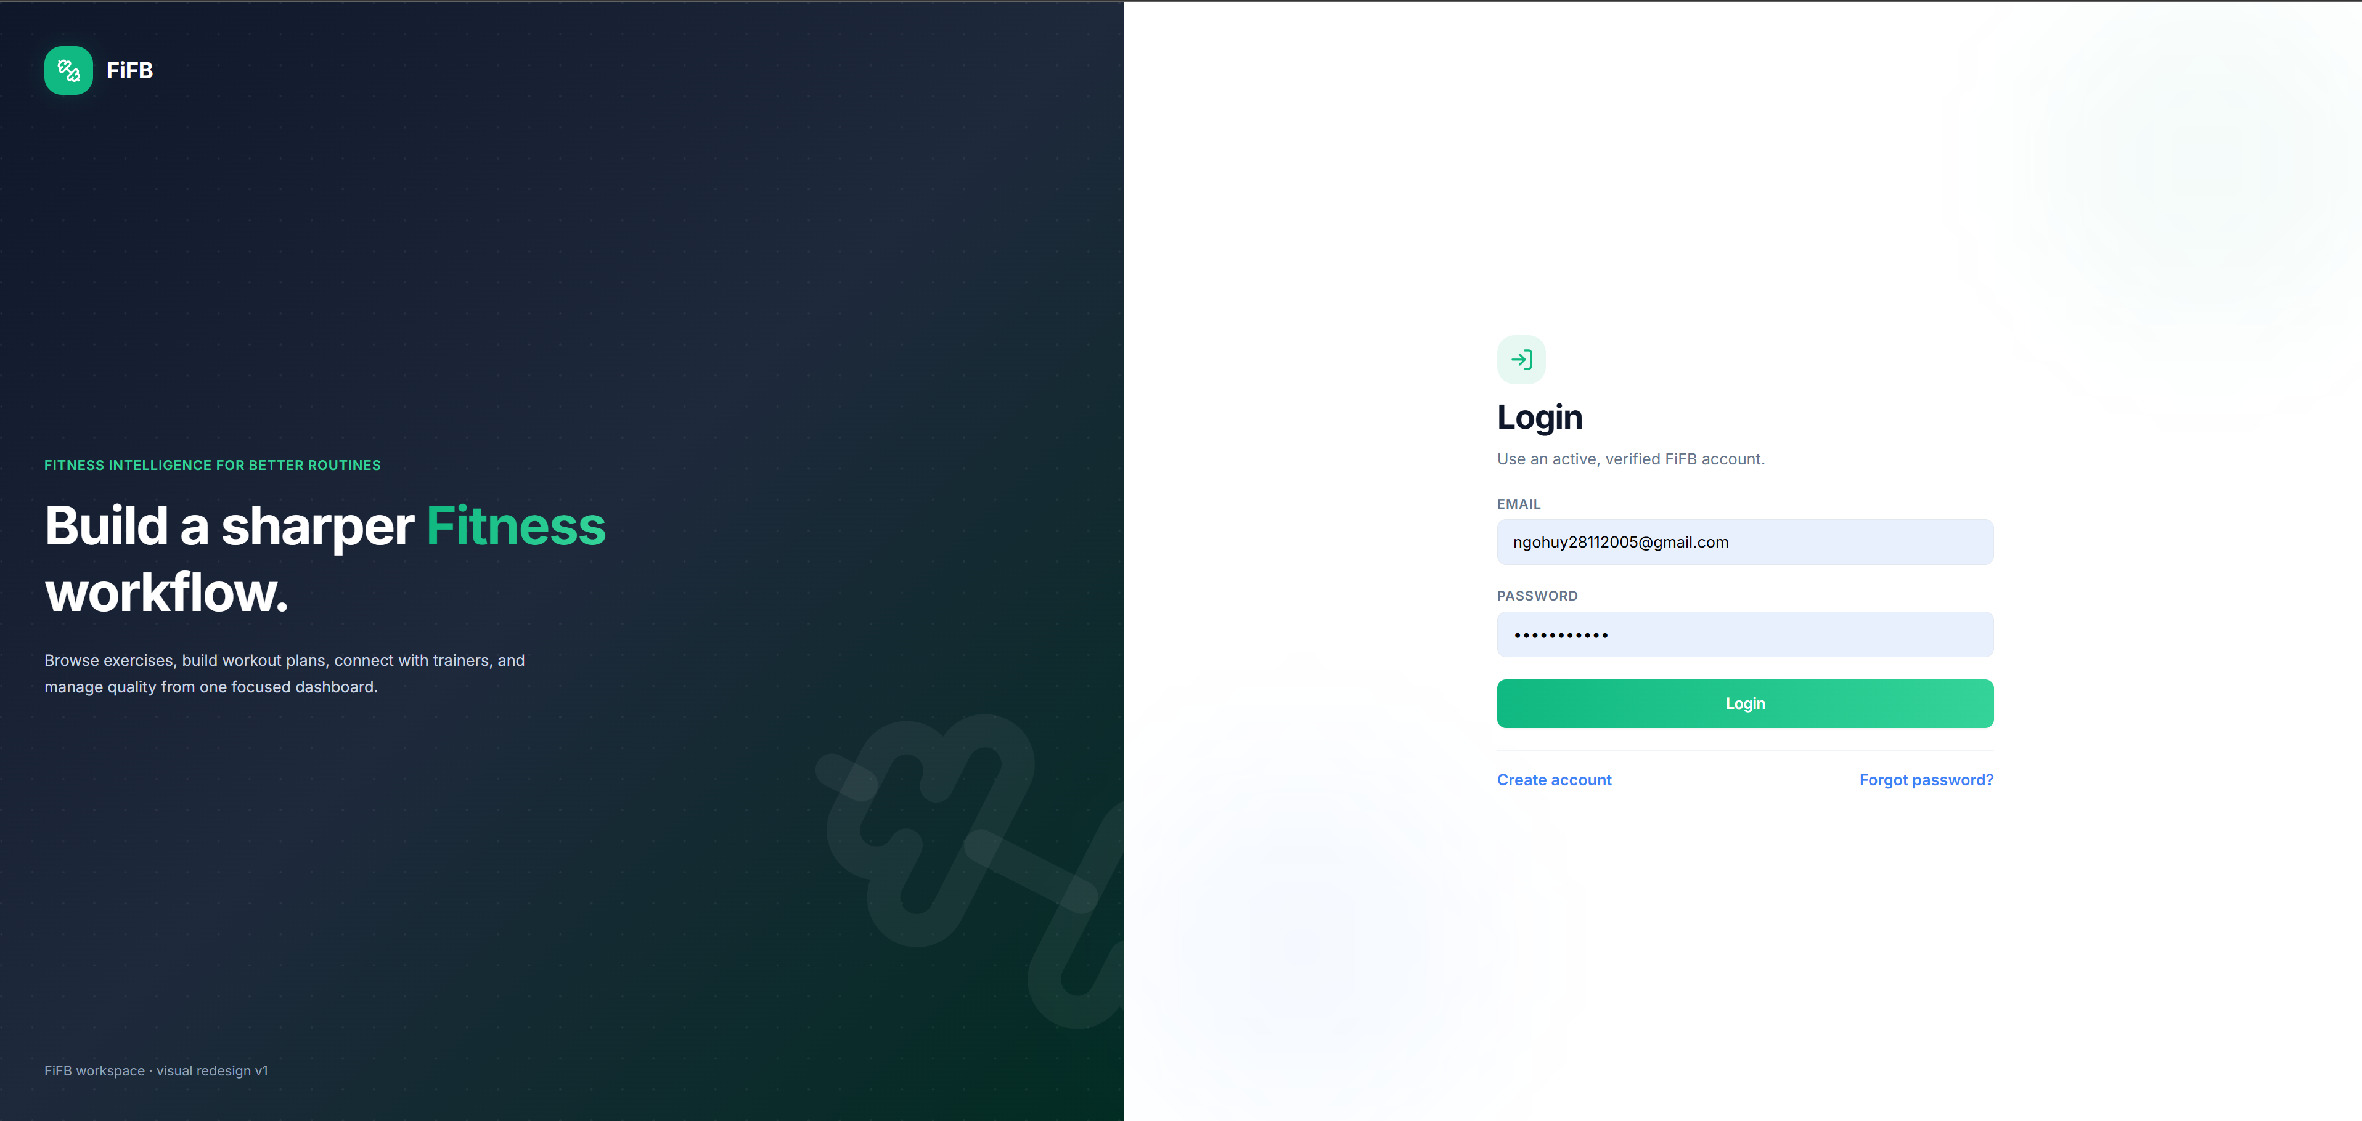
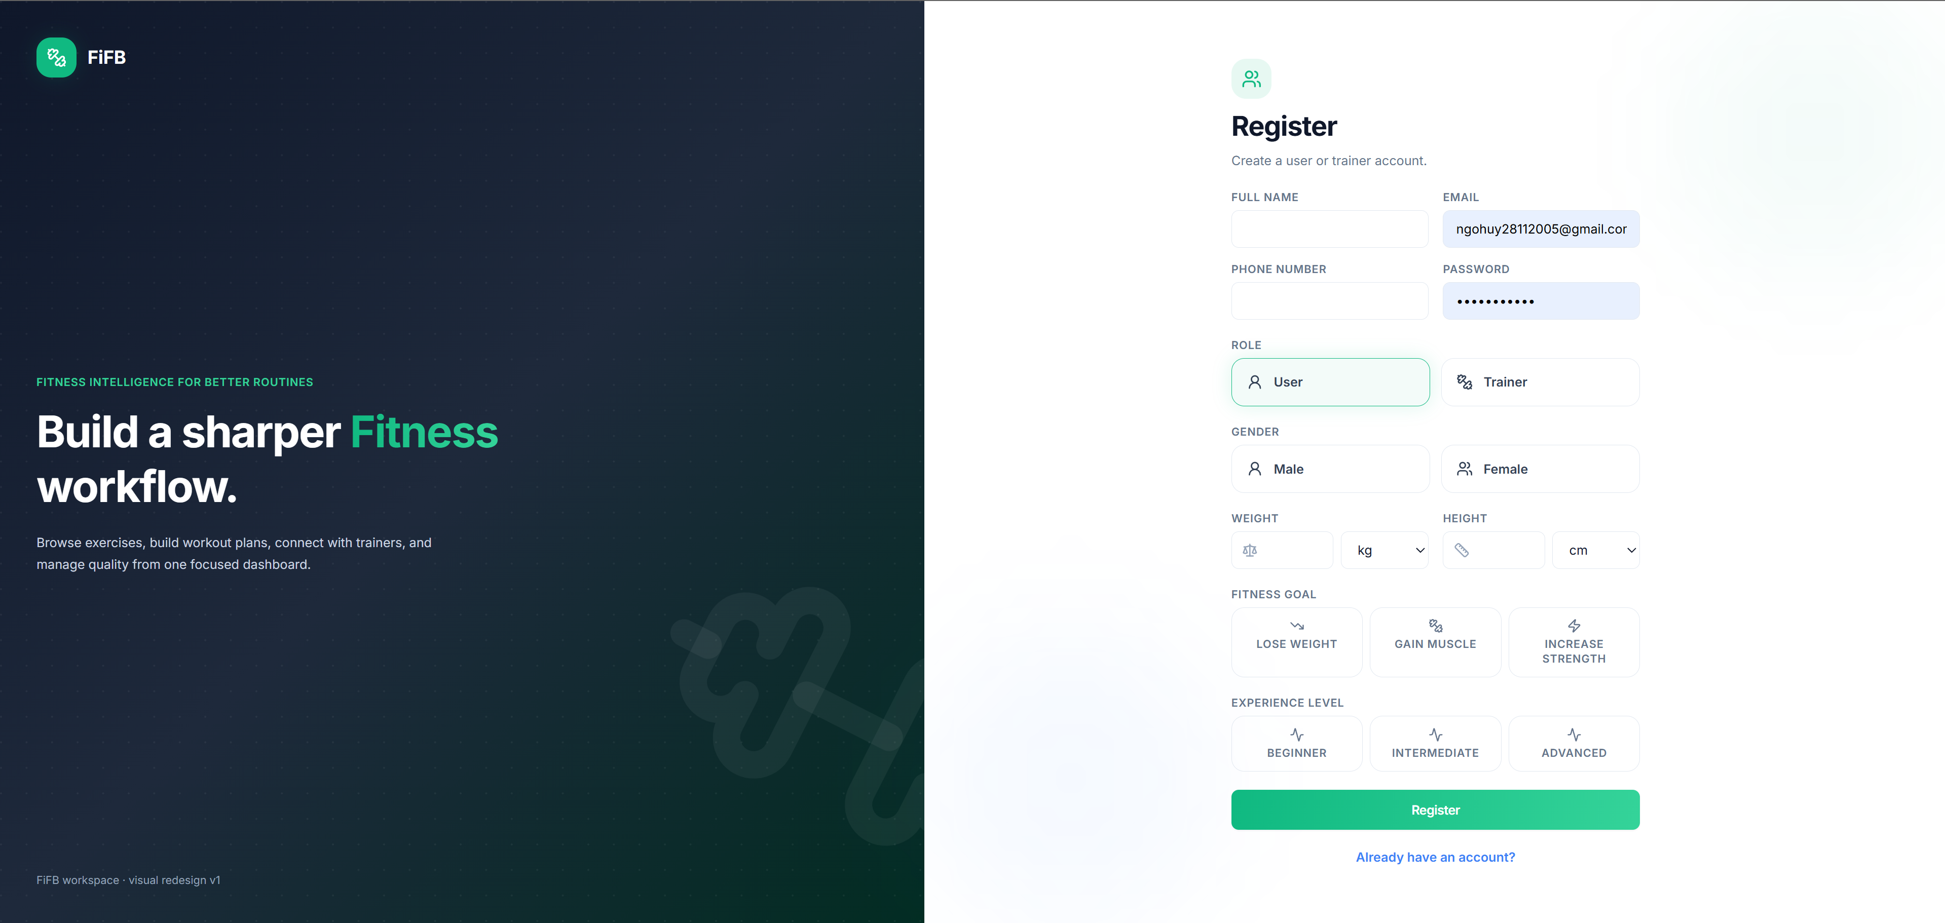
Figure 5.1. Login and registration interfaces
The authentication screens separate branding from the account form and provide direct transitions between login, registration, and recovery-related actions. The registration interface captures the information required to create an account and select an appropriate role. Form validation and backend error messages are expected to prevent incomplete or invalid submissions from being silently accepted.
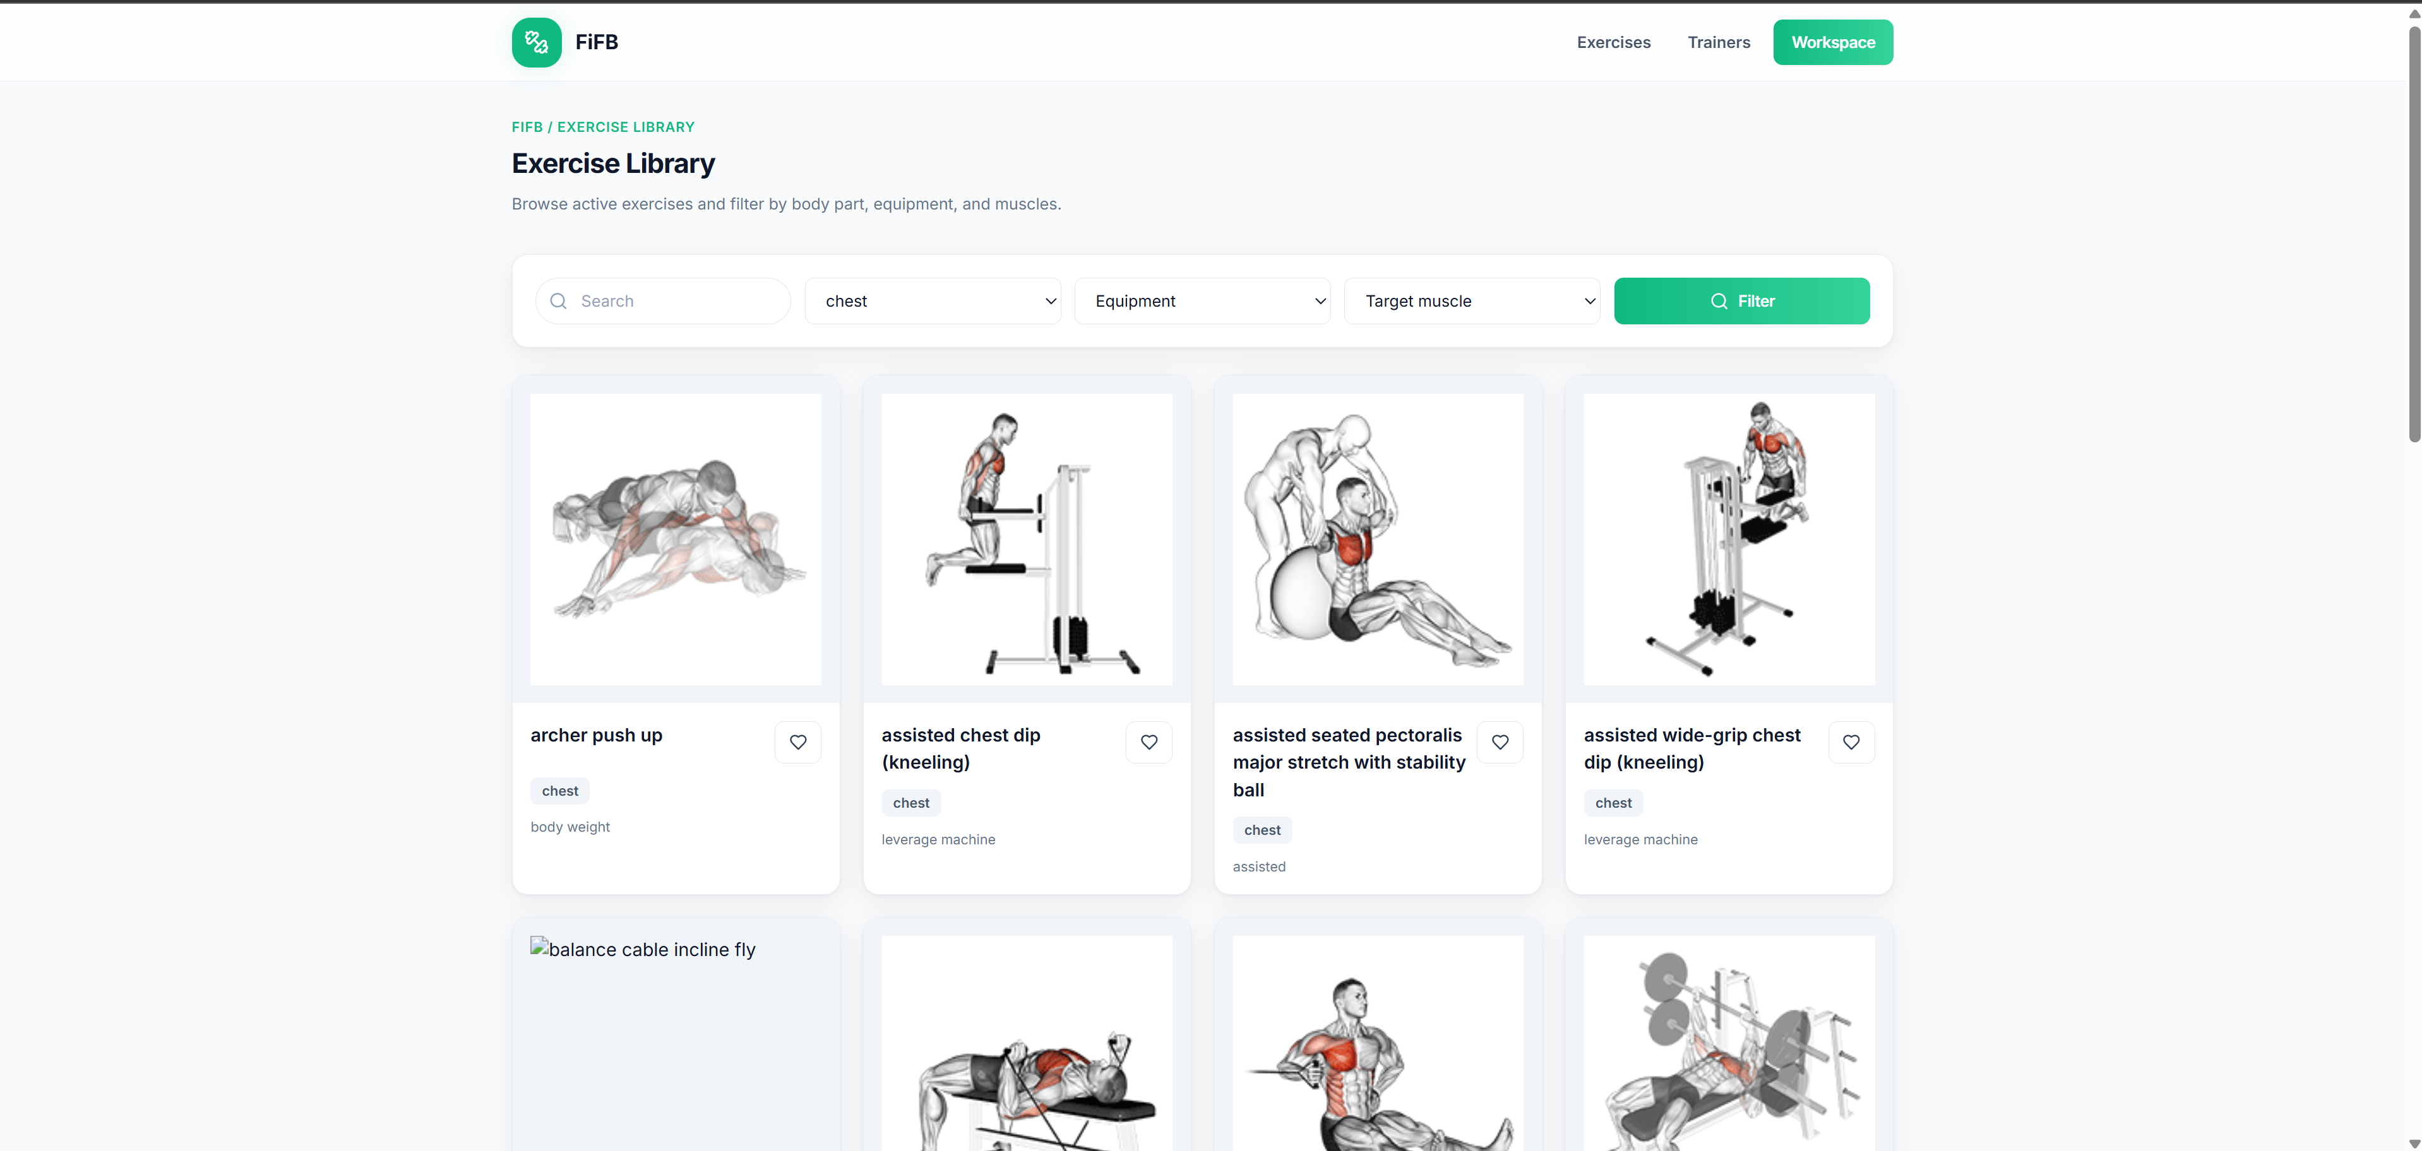
Figure 5.2. User exercise library with search and taxonomy filters
The exercise-library interface presents a search field and structured filters above a card-based result area. Each card provides an immediate visual reference and concise metadata, allowing the user to scan multiple options before opening a detail page. The layout reflects the market-survey conclusion that beginner discovery should remain direct and should not be hidden behind workout logging or business-management functions.
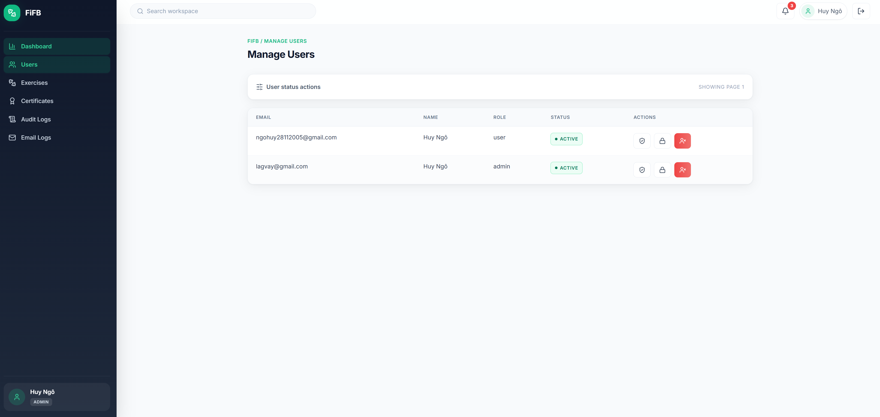
Figure 5.3. Admin user-management interface
The user-management screen places account records in a table and exposes status-related actions within the administrative layout. Search and filtering reduce the amount of information displayed at one time.
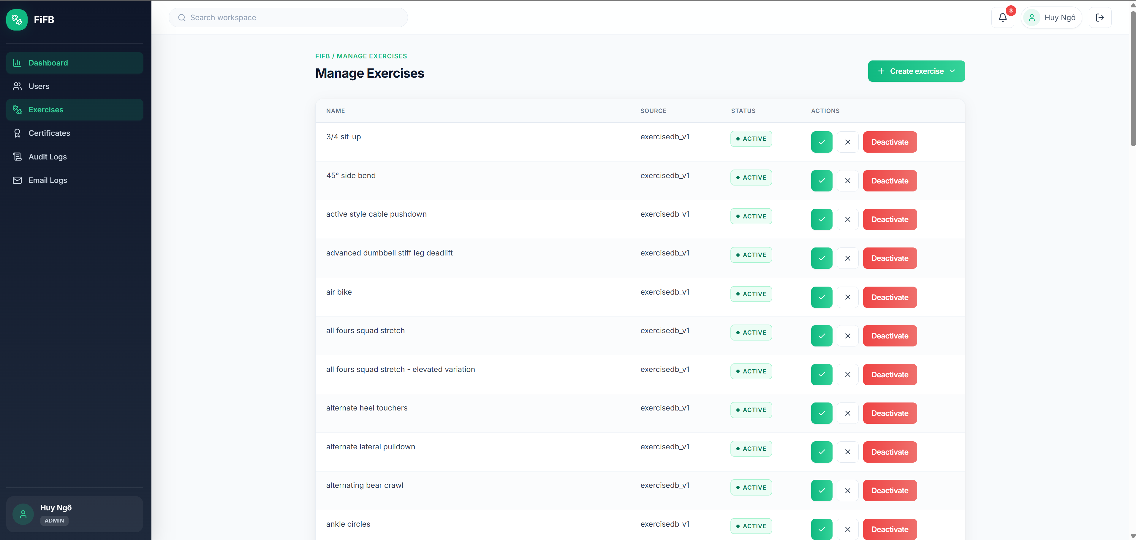
Figure 5.4. Admin exercise-management interface
The exercise-management screen displays content records and their lifecycle state, together with administrative actions. This interface supports the moderation model in which exercise data are governed rather than published without review.
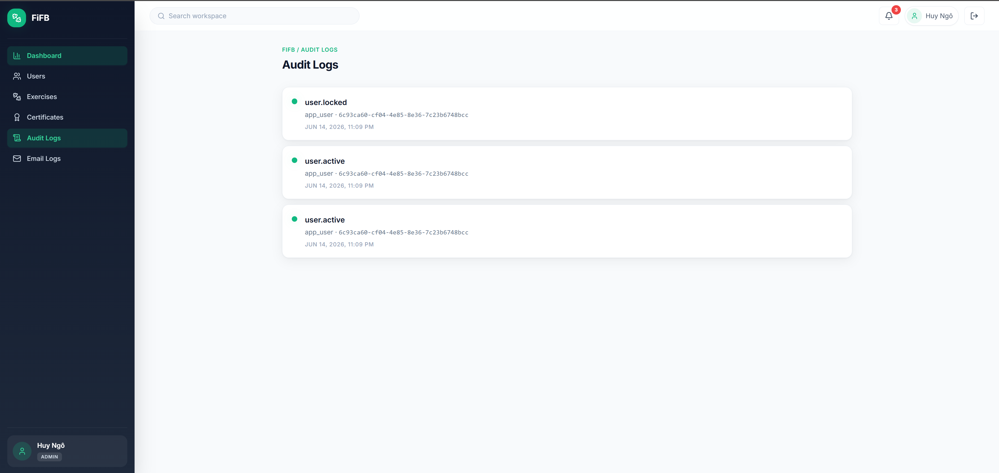
Figure 5.5. Administrative audit-log interface retained from the broader repository
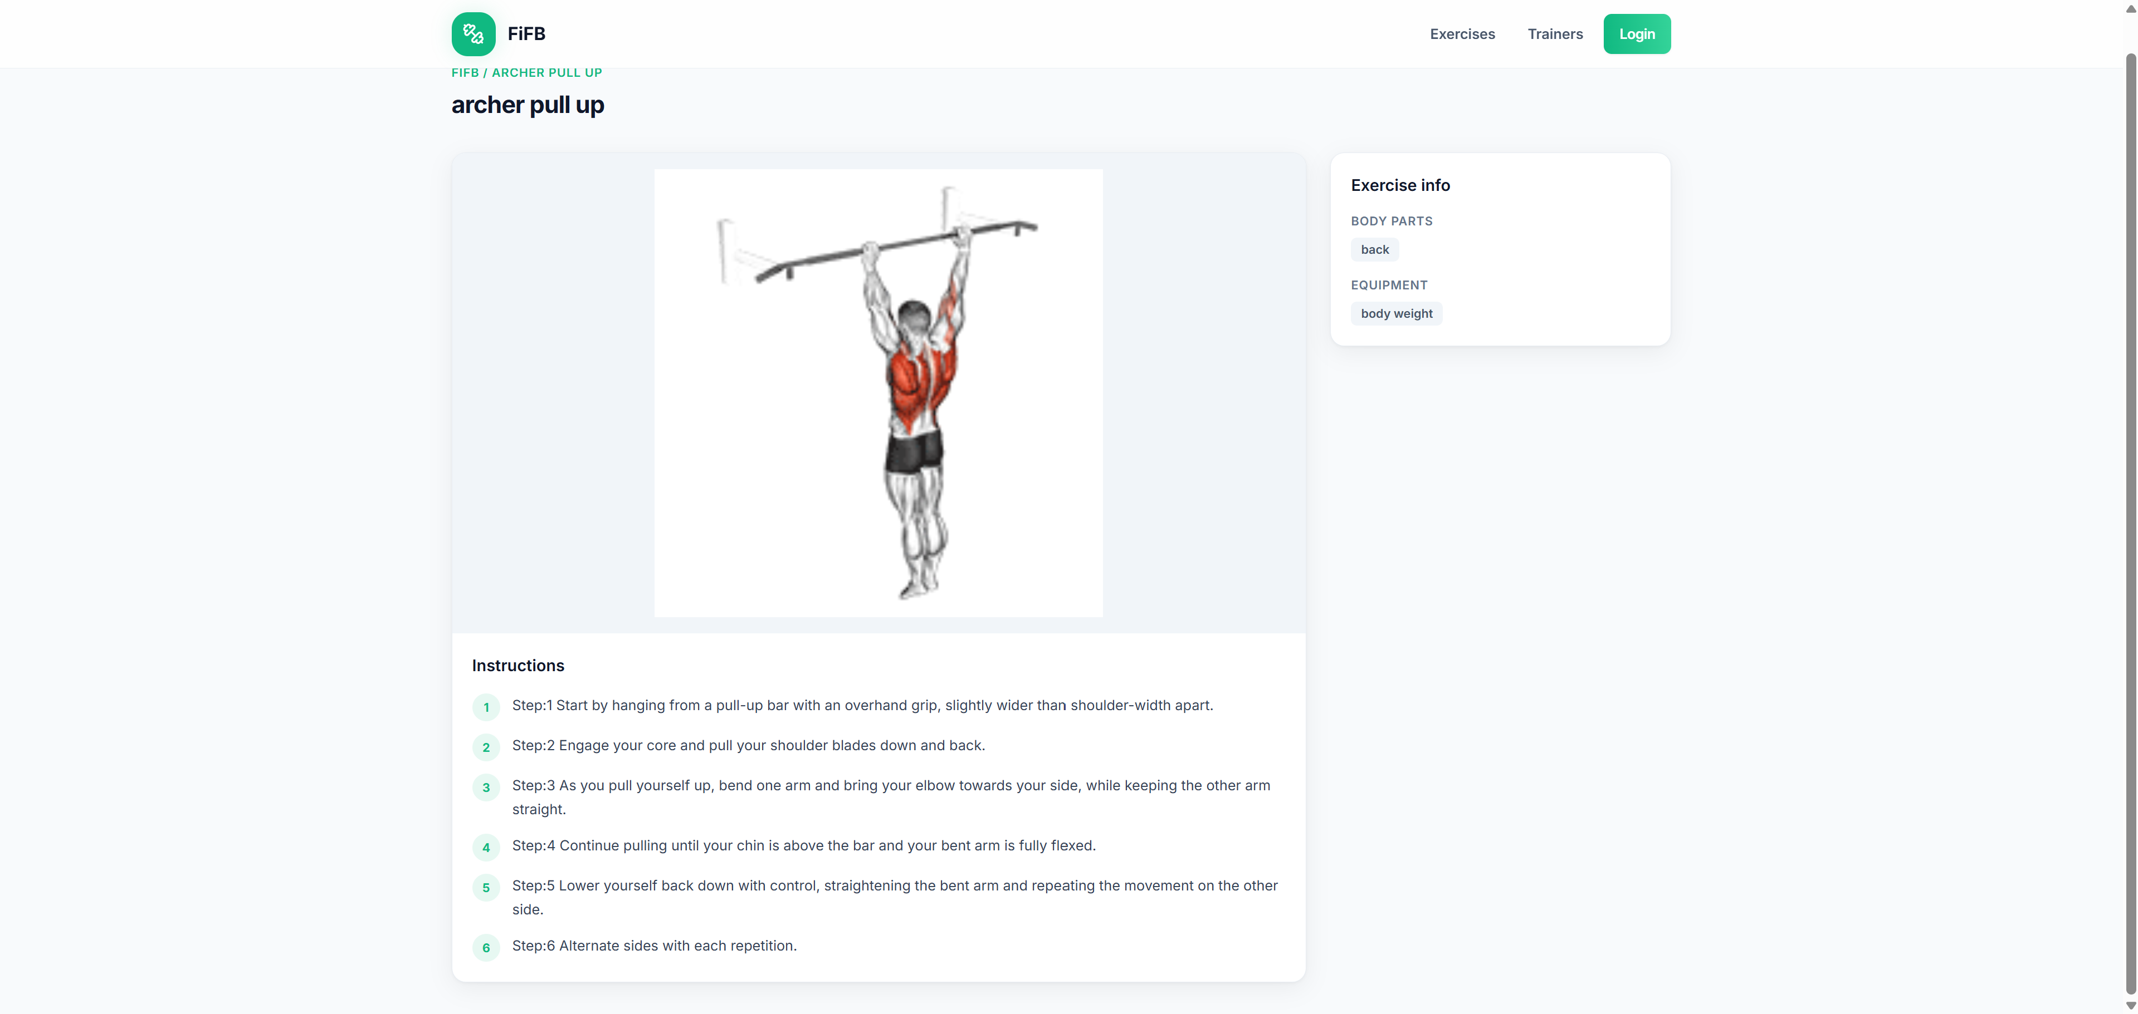
Figure 5.5. Exercise-detail page

5.6 Qualitative Evaluation of Software Quality
Usability is supported by role-specific navigation, visible search controls, card-based exercise presentation, reusable status indicators, and consistent form patterns. The current evidence is visual and implementation-oriented; no user study has yet measured task completion time, error rate, or perceived usability. Such a study would be appropriate after the interface and dataset stabilize.
Security is addressed through bcrypt password hashing, JWT verification, backend role checks, request validation, CORS, security headers, and parameterized SQL. These mechanisms provide a reasonable foundation, but production security would additionally require secret management, token-revocation policy, dependency monitoring, security testing, and operational logging.
Maintainability is one of the stronger aspects of the repository. Backend domain modules follow a repeated layered pattern, and frontend pages are separated from API and route infrastructure. The modular structure enables optional features to exist without changing the central user and exercise modules. The principal maintainability risk is scope growth: extension modules must continue to respect boundaries instead of introducing duplicated identity, authorization, or exercise logic.
Data integrity is supported by normalization, foreign keys, status constraints, upsert logic, and transactions. The ExerciseDB import design reduces duplication and synchronizes taxonomy relationships. Reliability is supported by centralized error handling and frontend feedback components. Performance has not been quantitatively assessed, although pagination and indexed relational queries are appropriate design choices for the current scale.

5.7 Limitations
The first limitation is the absence of archived quantitative evaluation evidence. The report does not contain a complete Jest or Supertest execution log, code-coverage result, end-to-end test report, response-time benchmark, or load test. Consequently, the evaluation cannot state numerical reliability or performance. The next phase should automate the principal role scenarios and preserve build and test outputs as project artifacts.
The second limitation is data provenance and quality control. ExerciseDB supplies a useful initial dataset, but imported records may contain naming inconsistencies, incomplete instructions, media availability changes, or content that requires expert review. The Admin moderation model helps, but the system still requires explicit data-quality rules and a repeatable import audit process.
The third limitation is that the Trainer workflow remains foundational. Profile and exercise submission are sufficient to demonstrate role separation, but they do not yet establish a complete support relationship between trainers and users. Community interaction, reputation, reporting, moderation policy, and user safety require additional requirements analysis rather than only more interface pages.

5.8 Development Plan for GR2
Table 5.3. Proposed GR2 development plan
Priority | Planned work | Expected evaluation
Core verification | Add integration and end-to-end tests for login, role restrictions, user status, exercise lifecycle, Trainer submission, and search filters | Recorded test results, coverage, and reproducible execution
Data quality | Persist import logs, detect duplicates, review missing media or instructions, and define moderation criteria | Dataset statistics and quality report
Community refinement | Clarify trainer discovery, connections, reviews, reporting, and moderation without turning the product into gym-facility software | User journeys and role-specific acceptance tests
UI/UX | Improve responsive behavior, accessibility, content hierarchy, and Vietnamese localization | Usability testing with beginner users
AI-assisted support | Investigate personalized recommendation, conversational guidance, or movement-related assistance within clear safety boundaries | Baseline comparison, task-specific metrics, and human review
Operations | Strengthen deployment, monitoring, secret management, caching, and real-time reliability where required | Deployment checklist and operational test evidence

The AI work should begin with a narrowly defined task. For example, an exercise recommender could use user goals, available equipment, and experience level, while a conversational assistant could answer questions only from the verified FiFB knowledge base. Any posture or technique analysis would require an appropriate dataset, expert labeling, privacy controls, and safety evaluation. The GR2 contribution should therefore be measured by demonstrated user value and validated behavior rather than by the mere presence of an AI API.

References
[1] World Health Organization, “Physical activity,” Fact Sheet, 26 June 2024. https://www.who.int/news-room/fact-sheets/detail/physical-activity
[2] World Health Organization, Global levels of physical inactivity in adults: off track for 2030, 2024. https://www.who.int/publications/i/item/9789240096905
[3] JEFIT, “Workout Planner and Tracking Application.” https://www.jefit.com/
[4] Hevy, “Workout Tracker and Gym Logger.” https://www.hevyapp.com/
[5] ABC Trainerize, “Personal Training Software for Fitness Professionals.” https://www.trainerize.com/
[6] Nike, “Nike Training Club App.” https://www.nike.com/vn/ntc-app
[7] ExerciseDB, “EXERCISEDB V1 API – Free Version Documentation.” https://oss.exercisedb.dev/docs
[8] Meta Open Source, “React Documentation.” https://react.dev/
[9] Vite, “Vite Documentation.” https://vite.dev/
[10] React Router, “React Router Documentation.” https://reactrouter.com/
[11] Axios, “Axios Documentation.” https://axios-http.com/docs/intro
[12] Tailwind Labs, “Tailwind CSS Documentation.” https://tailwindcss.com/docs
[13] OpenJS Foundation, “Node.js Documentation.” https://nodejs.org/docs/latest/api/
[14] Express.js, “Express Web Framework Documentation.” https://expressjs.com/
[15] PostgreSQL Global Development Group, “PostgreSQL Documentation.” https://www.postgresql.org/docs/
[16] Supabase, “Database Documentation.” https://supabase.com/docs/guides/database
[17] IETF, RFC 9110: HTTP Semantics, 2022. https://www.rfc-editor.org/rfc/rfc9110
[18] IETF, RFC 7519: JSON Web Token (JWT), 2015. https://www.rfc-editor.org/rfc/rfc7519
[19] OWASP Foundation, “Password Storage Cheat Sheet.” https://cheatsheetseries.owasp.org/cheatsheets/Password_Storage_Cheat_Sheet.html
[20] Zod, “TypeScript-first Schema Validation.” https://zod.dev/
[21] Helmet, “Helmet Documentation.” https://helmetjs.github.io/
[22] Jest, “Jest Documentation.” https://jestjs.io/docs/getting-started
[23] SuperAgent Team, “Supertest.” https://github.com/ladjs/supertest
[24] N. D. Huy, “Graduation-Research-FiFB,” GitHub repository, 2026. https://github.com/ngohuyhust/Graduation-Research-FiFB
[25] ISO, “ISO/IEC 25010 – Systems and software Quality Requirements and Evaluation.” https://www.iso.org/standard/78176.html

Appendices

Appendix A – Core API Documentation
The complete endpoint specification is maintained in Document/API.md in the project repository. For the focused GR1 report, the relevant sections are authentication and token handling, User and role permissions, Trainer profile and exercise submission, exercise discovery and lifecycle management, taxonomy endpoints, and administrative user-status operations.

Appendix B – Database Schema
The complete schema is maintained in Document/DatabaseSQL-v2.txt. The focused analysis in Chapter 4 uses app_users, trainer_profiles, exercises, body_parts, equipments, muscles, exercise_body_parts, exercise_equipments, exercise_muscles, and audit_logs. Extension tables remain in the schema for the broader community direction.

Appendix C – Focused Repository Structure
Graduation-Research-FiFB/
├── Document/ API, database, problem statement, and diagrams
├── SystemDesign/ Broader architectural design artifacts
├── client/ React + Vite frontend
│ └── src/ API, components, contexts, hooks, layouts, pages, routes
├── server/ Node.js + Express backend
│ ├── scripts/ Migration and ExerciseDB import scripts
│ ├── src/ Configuration, database, middleware, modules, routes
│ └── tests/ Automated-test support
├── docker-compose.yml Multi-service local environment
├── render.yaml Deployment blueprint
└── .github/workflows/ CI workflow definitions
The focused GR1 modules are auth, users, trainers, exercises, exerciseTaxonomy, and admin; all other modules remain GR2 extensions and are not counted as completed GR1 objectives.

